Pre-read: Azure Storage for Forward Deployed Engineers
Oct 6, 2026 ·
Read this before the hands-on class (about 20 minutes). It explains what Azure Storage is, which part to use for which job in an AI project, and what a Forward Deployed Engineer (FDE) must get right on day one at a client. The handout then walks you through doing it in Azure and in Google Cloud (GCP).

Why storage comes first
Every AI solution you deploy at a client starts with the client's data, and that data needs a safe, governed home in the cloud before any model touches it.
As an FDE you sit inside the client's team and turn an AI idea into a working system in their environment. A typical week-one ask: "Build a chatbot that answers from our policy PDFs and support tickets." Before you write a prompt, you must answer:
- Where do the client's files land? PDFs, CSVs, images, call recordings.
- Who can read them? Your app, the client's analysts, nobody else.
- How long are they kept, and how much does that cost?
- What happens when the pipeline adds new files every night?
Azure Storage answers all four. Get it wrong and you leak client data, run up a bill, or build a RAG system on files nobody can find. Get it right and every later step (indexing, embeddings, the app) plugs straight in.

Where storage sits in an AI solution
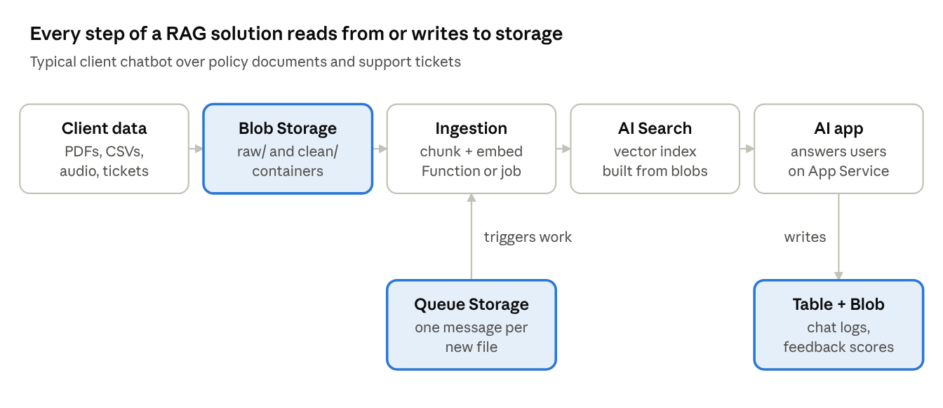
storage in a RAG solution · storage services highlighted
The highlighted boxes are Azure Storage. Client files land in Blob Storage, a queue message tells the ingestion job to chunk and embed each new file, AI Search builds its vector index from the blobs, and the app writes chat logs and feedback back to storage.

One storage account, five services
You create one storage account (a named container for everything, e.g. stacmeai01), and it gives you five services, each with its own web address.
Service | What it stores | Address | Use it in AI work for | Everyday analogy
Blob Storage | Any file ("blob") inside containers | https://<account>.blob.core.windows.net | Raw client documents, images, audio, model files, training data, chat logs | Google Drive for apps
Data Lake Storage Gen2 | Blobs, but in real folders with permissions per folder | https://<account>.dfs.core.windows.net | Big datasets processed by Spark, Databricks, Fabric, ML pipelines (raw → cleaned → curated) | A well-organised company file server
Azure Files | File shares you mount as a drive (SMB/NFS) | \\<account>.file.core.windows.net\<share> | Shared folders for legacy apps, notebooks, or VMs that expect a drive letter | A shared network drive (Z:)
Queue Storage | Small messages, processed in order by workers | https://<account>.queue.core.windows.net | "New file uploaded → please embed it" jobs between pipeline steps | A to-do ticket rail in a kitchen
Table Storage | Simple rows of key-value data, no joins | https://<account>.table.core.windows.net | Cheap metadata: which file was indexed when, per-user settings, feedback scores | A big spreadsheet keyed by ID
Managed Disks are also Azure storage but are not inside a storage account. They are the hard drives attached to virtual machines (for example a GPU VM running an open-source model).
Rule of thumb for AI projects: documents and data go to Blob (or Data Lake Gen2 when analytics tools process them at scale). Use Queues to connect pipeline steps and Tables for lightweight metadata. Use Files only when something needs a mounted drive.
How the parts nest: storage account → container → blob. Example: stacmeai01 → client-docs → policies/refund-policy.pdf.

Four settings you choose when creating an account
These four choices decide cost, speed and safety. Changing some of them later is hard, so decide with the client up front.
1. Performance
- Standard (general-purpose v2): normal disks. The right default for almost every AI project.
- Premium: SSD, low latency, higher price. Only for heavy, latency-sensitive workloads.
2. Redundancy: how many copies Azure keeps, and where
Option | Copies | Protects against | Typical AI use
LRS (locally redundant) | 3, in one datacenter | A disk or server failing | Labs, dev, data you can rebuild
ZRS (zone-redundant) | 3, across 3 availability zones in one region | A whole datacenter going down | Production apps in one region
GRS (geo-redundant) | 6: 3 local + 3 in a paired region | A whole region going down | Client data that must survive a disaster
GZRS (geo-zone-redundant) | 6: 3 across zones + 3 in a paired region | Datacenter and region failures | Critical production data
Add RA- (read access, e.g. RA-GRS) when the app must still read from the second region during an outage. In class we use LRS because it is the cheapest.
3. Access tier: pay less for data you rarely touch
Tier | Online? | Minimum stay | Use for
Hot | Yes | none | Files the AI app reads every day (current documents, index sources)
Cool | Yes | 30 days | Last quarter's raw uploads, older chat logs
Cold | Yes | 90 days | Data kept for audit, read a few times a year
Archive | No: must be rehydrated first, up to 15 hours | 180 days | Long-term retention a client is legally required to keep
Storage gets cheaper as you move down the table, but reading gets more expensive. Deleting or moving a file before its minimum stay costs a fee. Lifecycle management rules move files between tiers automatically, for example "move to Cool after 30 days without access, delete after 365 days".
4. Hierarchical namespace (HNS)
Turning this on makes the account a Data Lake Storage Gen2 account: real folders, fast folder renames, and permissions per folder. Turn it on when data engineering or analytics tools (Databricks, Synapse, Fabric, Spark) will process the data. Leave it off for a simple app or RAG document store. You choose this at creation time.

Security: what an FDE must get right at a client
Client data is the client's most sensitive asset. A storage mistake is the fastest way to lose a client's trust, so treat these as non-negotiable.
Three ways to prove who you are to storage, from best to worst:
Method | How it works | When to use
Microsoft Entra ID + RBAC (role-based access) | A user or app signs in; a role on the account says what it may do | Default for everything
SAS token (shared access signature) | A URL with a signed, time-limited permission added to the end | Giving someone one file for a few hours, e.g. a download link
Account key | A master password for the whole account | Avoid. Anyone with it can do anything. Many clients disable keys entirely
Managed identity lets an Azure app (App Service, Function, AI Search) sign in to storage with no password in code. Turn it on for the app, then give that identity a role on the storage account.
The roles you will use most:
- Storage Blob Data Reader: can read blobs. Give this to your AI app or search indexer.
- Storage Blob Data Contributor: can read, write and delete blobs. Give this to the ingestion pipeline or yourself in dev.
- Storage Account Contributor: manages the account settings but cannot read data. A common surprise: being Owner of the account does not let you read blobs through Entra ID; you still need a Data role.
Network and data protection checklist:
- ☐ Public blob access disabled: no anonymous internet reads.
- ☐ Private endpoint or firewall: client data reachable only from their network or your app.
- ☐ Encryption at rest is on by default. Ask if the client requires customer-managed keys in Key Vault.
- ☐ Soft delete for blobs and containers: deleted files can be recovered for a set number of days.
- ☐ Versioning: every overwrite keeps the old version.
- ☐ Diagnostic logs sent to Log Analytics so you can show who read what.
- ☐ Data residency: confirm the region the client is allowed to use (e.g. data must stay in India: Central India / South India).

Azure and GCP side by side
FDEs move between clients on different clouds. The ideas are the same; the names change. Use this table to translate.
Concept | Azure | Google Cloud (GCP)
Top-level home for storage | Storage account (inside a resource group) | Project (buckets live directly in it)
Folder-like container | Container | Bucket
A stored file | Blob | Object
Object storage service | Blob Storage | Cloud Storage (GCS)
Data lake with real folders | Data Lake Storage Gen2 (HNS on) | Cloud Storage bucket with hierarchical namespace
Mounted file share | Azure Files | Filestore
Messages between pipeline steps | Queue Storage (or Service Bus) | Pub/Sub (or Cloud Tasks)
Simple key-value table | Table Storage (or Cosmos DB) | Firestore / Bigtable
VM disks | Managed Disks | Persistent Disk / Hyperdisk
Frequently used tier | Hot | Standard
30-day minimum tier | Cool | Nearline
90-day minimum tier | Cold | Coldline
Long-term tier | Archive (180 days, offline) | Archive (365 days, still online)
Automatic tiering | Lifecycle rules | Lifecycle rules or Autoclass
One copy per region | LRS / ZRS | Region location
Copies in two regions | GRS / GZRS | Dual-region or multi-region location
Time-limited link | SAS token | Signed URL
Access control | Entra ID + RBAC roles | IAM roles (e.g. Storage Object Viewer)
Password-less app identity | Managed identity | Service account (attached to the app)
Command-line tool | az storage ... | gcloud storage ...
Python library | azure-storage-blob | google-cloud-storage
India regions | Central India (Pune), South India (Chennai) | asia-south1 (Mumbai), asia-south2 (Delhi)
One difference to remember: Azure's Archive tier is offline (you wait hours to read), while GCP's Archive class can be read immediately, at a higher retrieval fee.

FDE day-1 storage checklist at a client
Ask these before you create anything. Each answer maps to a setting you learned above.
Ask the client | It decides
Which region must the data stay in? | Region
How bad is it if this data is lost or unavailable for a day? | Redundancy (LRS, ZRS, GRS, GZRS)
How often will the AI app read these files? How long must we keep them? | Access tier and lifecycle rules
Will data engineers process this with Spark, Databricks or Fabric? | Hierarchical namespace on or off
Who and what must read or write the data? | RBAC roles and managed identities
Must storage be unreachable from the public internet? | Private endpoint and firewall
Do you need your own encryption keys? | Customer-managed keys in Key Vault
What naming and tagging rules does your cloud team use? | Account, container and tag names

Glossary
Term | Meaning
Blob | Any file stored in Azure Blob Storage
Container | A folder-like group of blobs inside a storage account
Object, bucket | GCP's words for blob and container
RAG | Retrieval-augmented generation: the AI looks up your documents before answering
Ingestion | Moving client data into cloud storage
Indexer | A service that reads files from storage and builds a search or vector index
Embedding | A list of numbers that represents the meaning of a text, used for vector search
Rehydrate | Bringing an archived blob back online so it can be read
RBAC | Role-based access control: who may do what, given as roles
SAS | Shared access signature: a time-limited permission inside a URL
Managed identity | An Azure-managed login for an app, so no password sits in the code
HNS | Hierarchical namespace: real folders, which makes the account a data lake

Think about these before class
- A client uploads 2,000 policy PDFs once. The chatbot reads them daily for a year. Which tier, and which redundancy?
- Call recordings must be kept 7 years for compliance but are almost never played. Which tier, and why must you warn the client about Archive's read time?
- Your AI Search indexer needs to read a container. Which role do you give it, and to which identity?
- A client's analyst asks for one report file for a meeting tomorrow. Do you share the account key, a SAS link, or add them to RBAC?
- The same client later moves to GCP. What are the GCP names for: storage account, container, Cool tier, SAS token?

